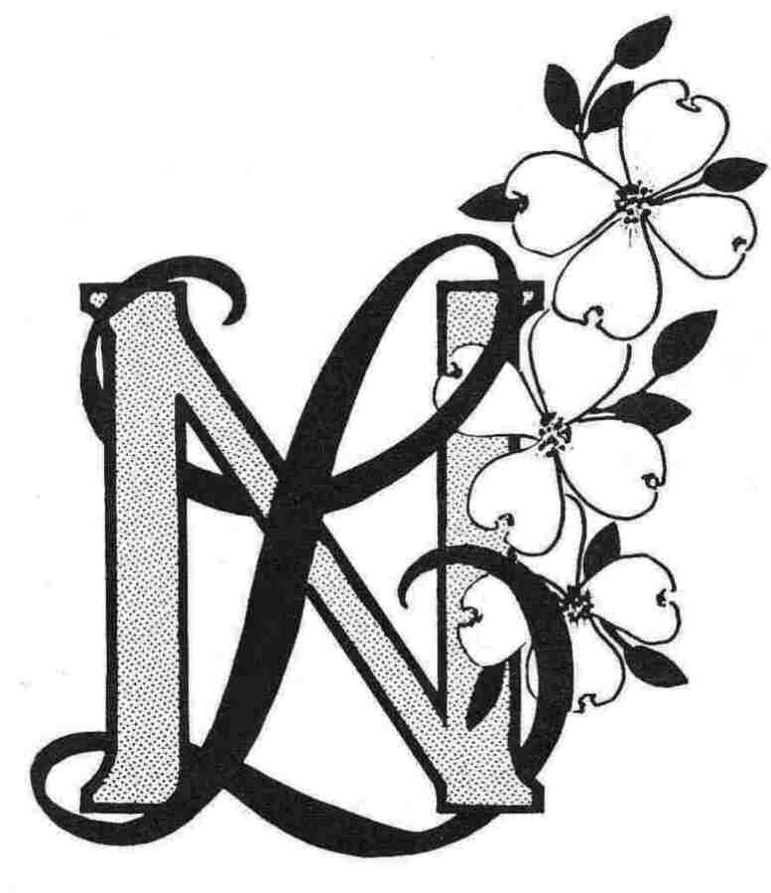
Newcomers/Longtimers
Member Registration Form (Revised 5/18/26)
Membership Dues: $30.00 Cash or Check (payable to N/L)

New Member: |  |  | _____ |  |  |  |  |  |  | Current Member Information Revisions |  |  |  |  |  |  |  |  |  |  |  |  | _____ |  |  |  |  |  | Date: |  |  | ________
(Please print following Information) |  |  |  |  |  |  |  |  |  |  |  |  |  |  | Birthday: Month & Day |  |  |  |  |  |  |  |  |  |  |  |  |  |  | ______________
Name: |  | _________________________ |  |  |  |  |  |  |  |  |  |  |  |  |  | Spouse/Significant Other: |  |  |  |  |  |  |  |  |  | ____________________
Mailing Address: |  |  |  |  |  | _______________________________________________________________
City: | ________________________________ |  |  |  |  |  |  |  |  |  |  |  |  |  |  |  |  | State: |  |  | ________ |  |  |  |  |  | Zip: |  |  |  | ___________
E-mail Address: |  |  |  |  | _______________________________________
Primary Contact : |  |  |  |  |  |  |  | Cell |  |  | _____________________ |  |  |  |  |  |  |  |  |  | Home |  |  | ________________________
Let us know if you have any special talents you would like to bring, such as party planning, crafts, computer skills and if you would be interested in getting more involved with our group.
Also please let me know how long you have lived in the area and where you are from.
Do you Work? |  |  |  | No: |  |  |  |  | _____ |  |  |  | Yes: _____ |  |  |  | Full Time: _________ |  |  |  |  |  |  |  |  |  | Part Time: _________
How did you find out about Newcomers Longtimers? |  |  |  |  |  |  |  |  |  |  |  |  |  |  |  |  |  |  |  | __________________________________
Here is a list of what is currently available for this fun group. You will receive email invitations for each event (yes, it is a lot of emails but totally worth it )
Please circle those that interest you.
Everybody Bunco |  |  |  |  |  |  | Happy Hour |  |  |  |  |  |  | Crafty Ladies |  |  |  |  | Ladies Luncheon |  |  |  |  |  |  |  |  | Working Women Weds
Ladies Bunco |  |  |  |  |  |  | Dining Out |  |  |  |  |  |  | Single Ladies |  |  |  |  | Pickleball |  |  |  |  |  |  |  |  | Triple Ds
Euchre |  |  |  |  |  |  | Book Club |  |  |  |  |  |  | Mah Jong |  |  |  |  | Special Activities |  |  |  |  |  |  |  |  | Canasta

Date__________________ Signature______________________________________________

Please mail this form and dues to Club Treasurer:
Linda North, 967 Country Club Dr., Lake Ozark, MO 65049
or email form to NewcomersMembershipLOZ@gmail.com
& pay by Venmo@Judith-Cullen-1 (be sure and note your name!)

