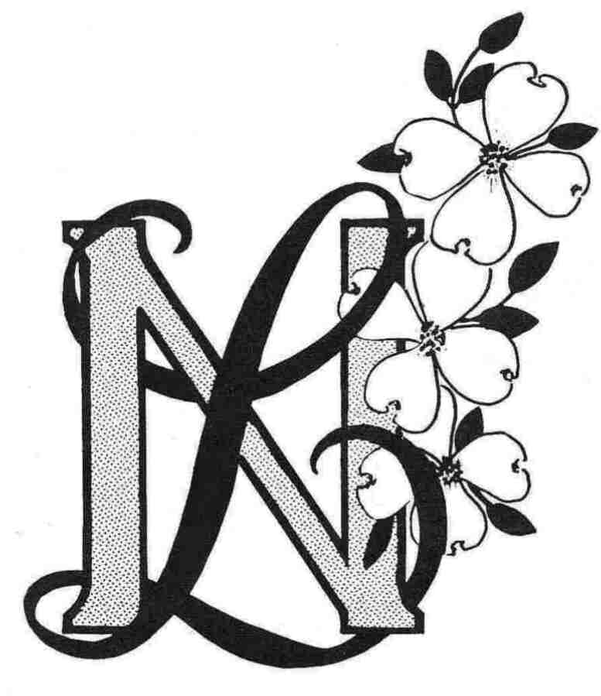
Newcomers Longtimers
Member Registration Form (Revised 3/1/23)
Membership Dues: $30.00 (Check or Cash) (June 2023-May 2024)
New Member____ Current Member Information Revisions____ Date________
(Please print)

Name_______________________________________________________________________

Spouse/Significant Other_________________________________________________________

Mailing Address_______________________________________________________________

City___________________________________ State____________ Zip__________________

E-mail Address________________________________________________________________

Primary Contact Number ____________________Birthday: Month _______ Day_______

Do you have special skills/talents i.e bookkeeping; leadership; computer; graphics, etc that you
might volunteer?

___________________________________________________________________________

___________________________________________________________________________

How did you find out about Newcomers Longtimers? ______________________________

What are you interested in? Circle as many as you wish.

Everybody Bunco Ladies Bunco Happy Hour Dining Out Diners, Drive-ins and Dives Monthly Lunch

Book Club Hand and Foot Canasta Bridge Mahjong Crafternooners Single Ladies Working Women Weds

Pickle Ball Special Activities

Date__________________ Signature______________________________________________

Please return this form and dues to the Membership Chair:
Paula Constantini, 128 Park Circle, Lake Ozark, MO 65049

